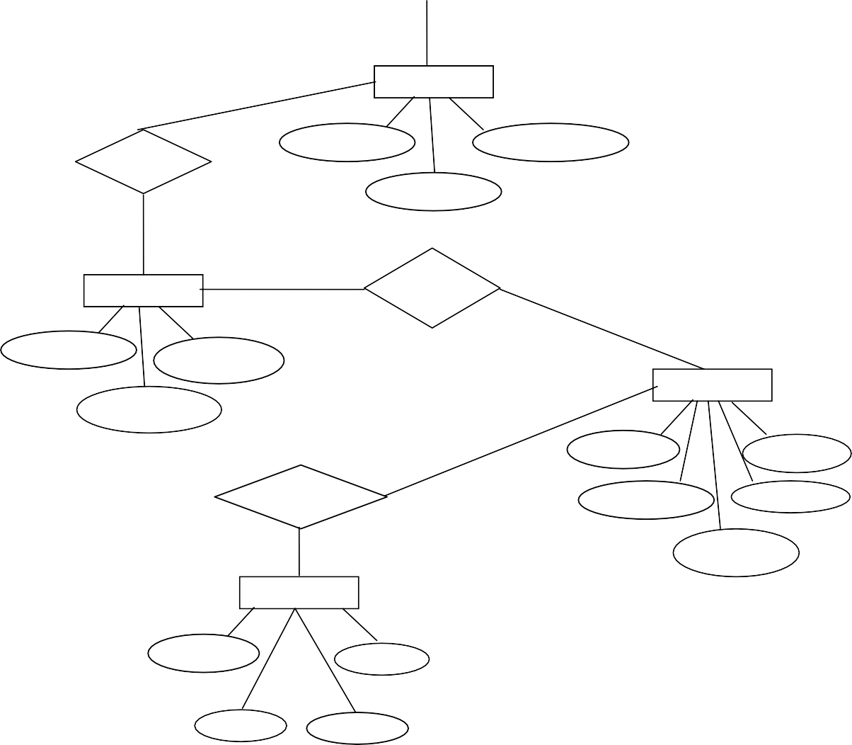

Published

by

Written

by

copies

Book_copies

Book_id

No_of_copie

in

Branch_id

Lib_branch

Loan

Branch_id

addrs

Book_loan

Brch_name

Book_id

Due_da

Loaned to

Branch_id

addrs

Card_no

borrower

Card_no

addrs

name

phone

name

addrs

phone

publisher

title

Book_id

publisher

book

Book_id

addrs

phone

author

**E-R diagram for Library Information System**